Device Name: Lenovo – Yoga C930

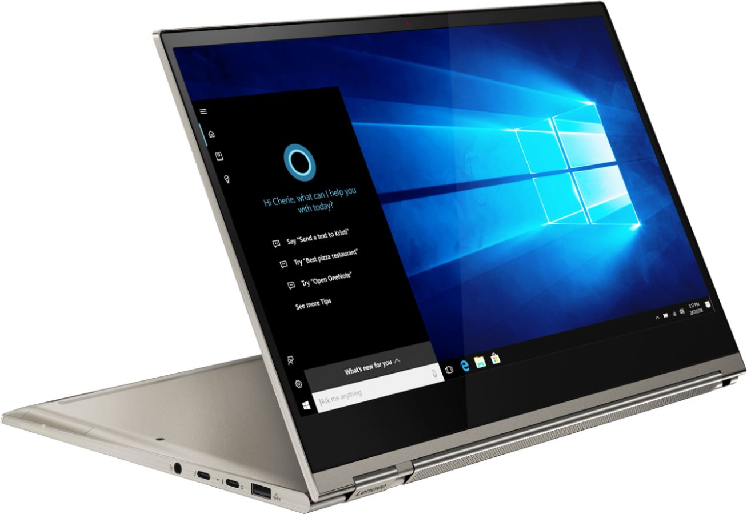

Price: $1600

**SPECIFICATIONS:**

|  |  |
| --- | --- |
| Processor: | Intel Core i7-8550U (1.8 GHz) |
| Memory: | 12 GB DDR4 |
| Storage: | 256 GB |
| Screen Size: | 15 |